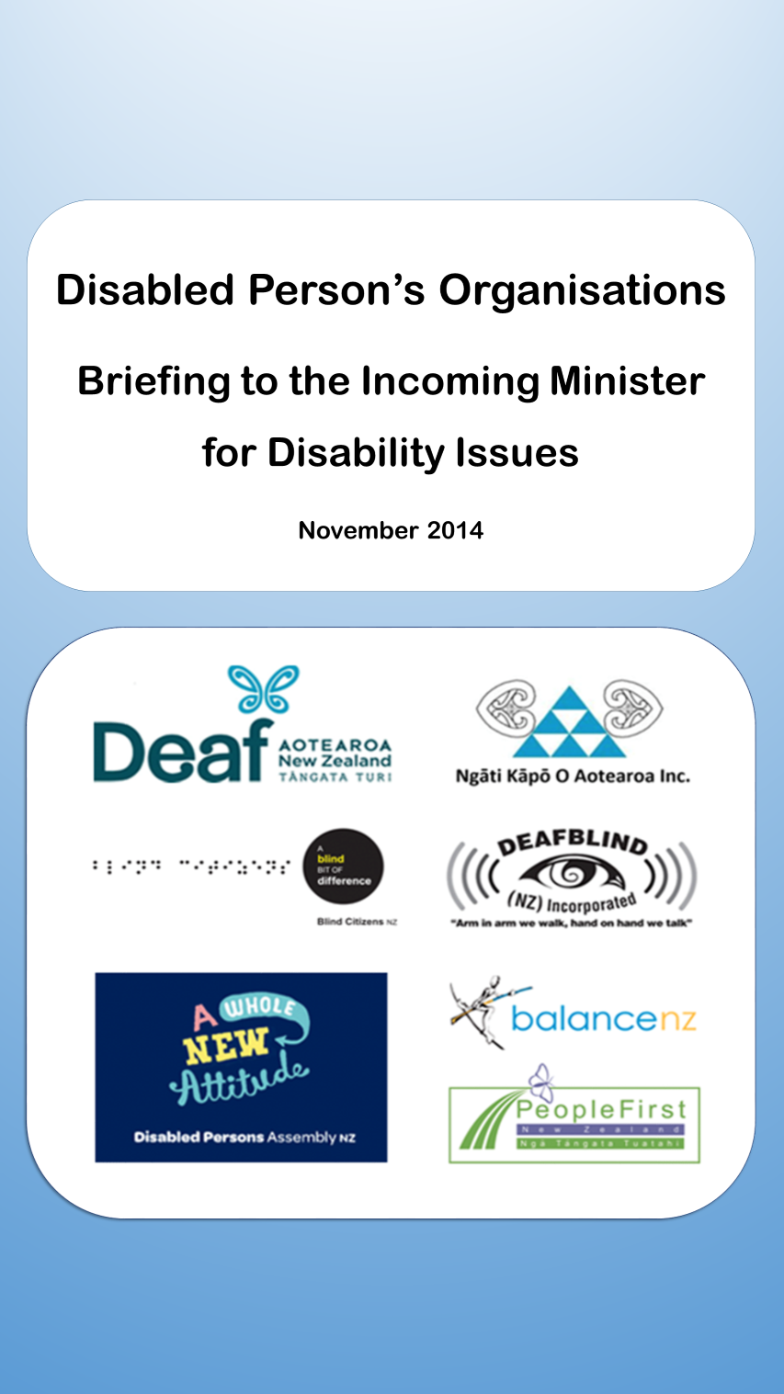

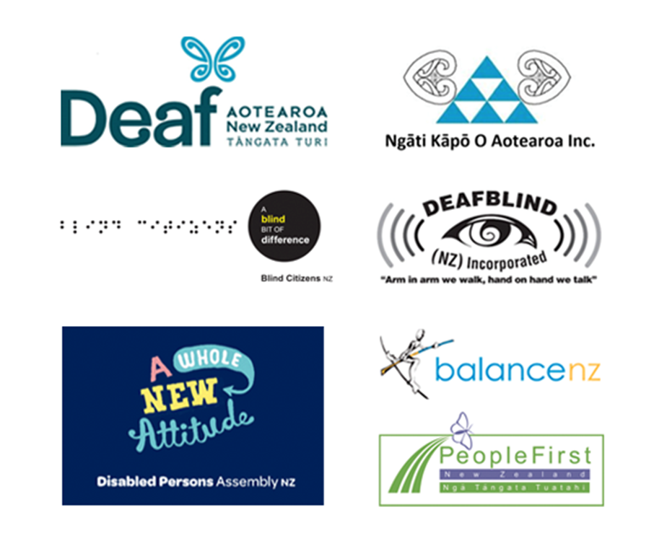
Karanga karanga karanga ra, karanga ki te ata hāpara e tohungia nei te rangi hou,
As we direct our collective voices to call to the dawn, to signify the coming of a new day,
tēnei te reo e karanga nei, tēnei te reo e mihi nei, tēnei te reo e kawea ra ngā wawata o tēnā o tēnā o tātou kua whetu rangitia.
heoi anō, moe mai rā i te rangimārie nōreira moe mai moe mai moe mai rā
the voices who call, the voices who greet, the voices who carry the dreams of those who dwell in the heavens like the stars which decorate the night sky, we acknowledge your contribution, so in your memory we bid you eternal peace.
Piki ake piki ake ko te reo pōwhiri ko te reo whakatau, ko te reo e kotahi ai ko kāpō, ko turi, ko hauā.
We extend our voices of welcome and friendship using the united voice of the disabled community of Aotearoa New Zealand.
He reo kōrero he reo wānanga he reo whakarite kia tū te ao e tūmanakohia ai.
This voice which is speaking, this voice of collaboration, will create pathways to an accepting world.
Nō reira ka tuku atu tēnei reo kia rere ai i ngā hau e whā, e rere e rere e rere rā!
We send forth this voice to the four winds, to take flight and be heard!
Ki mai koe ki ahau he aha te mea nui o te ao? Māku e ki atu, he tangata he tangata he tangata e!
Ask me, “What is the greatest thing in the world?”
I will reply, “It is people, it is people, it is people!”

Purpose of this BIM
- To deepen your understanding of disability issues
- To extend the working partnership between DPOs and Government
- To reinforce the DPO’s priority areas and action sought in the next 3 years.

Who are we?
- This report is from seven Disabled People’s Organisations (DPOs):
Association of Blind Citizens of New Zealand
Balance New Zealand
Deaf Aotearoa NZ Inc.
Deafblind NZ Incorporated.
Disabled Persons Assembly NZ Inc.
Ngāti Kāpō O Aotearoa Inc.
People First NZ Inc., Ngā Tāngata Tuatahi
- DPOs in New Zealand are identified by a number of attributes. This includes that they are all national organisations with a mandate to speak on behalf of their members, most of whom are disabled. Their governing boards are wholly or mostly comprised of disabled people.
- These DPOs represent the national voices of disabled people. One DPO has a pan disability focus on matters that affect all disabled people, others focus on specific groups of disabled people, ie: deaf people, blind and vision impaired people, people with mental health issues, deafblind people, Māori blind and vision impaired people and people with learning disabilities. Short descriptions of the seven DPOs are provided at the end of this document.
- All seven DPOs work towards visions of full and equal participation and full citizenship for disabled New Zealanders.
- The DPOs have a point of difference with disability services provider organisations that are not led by, and have a mandate to represent, disabled people.

Article 4.3
- Article 4.3 of the UN Convention on the Rights of Persons with Disabilities (Disability Convention) states that:
“In the development and implementation of legislation and policies to implement the present Convention, and in other decision-making processes concerning issues relating to persons with disabilities, States Parties shall closely consult with and actively involve persons with disabilities, including children with disabilities, through their representative organisations.”
- The working partnership between DPOs and the Government is based on agreed “principles of engagement” that are:
- Government will engage with DPOs as representatives of disabled people
- Involving the right people, at the right time, in the right work
- Valuing the contribution of each party and making it easy to engage
- Being open, honest, transparent and creative in our engagements
- Reviewing and learning how to engage with each other.
- Work to date on the DPOs and Government partnership has provided the context and now there is opportunity to put this into action. There are challenges for both government and DPOs in how they can coordinate themselves and work together better. Further gains can be made in clarifying processes to implement the engagement principles across all government agencies and addressing capacity and capability issues, to ensure a true partnership in all areas.

Disabled people’s voices

- Disabled people have said:
Nothing about us, without us.
We want more choice and control over our lives.
We want to be able to participate equitably.
No negative or discriminatory experiences in:
Health
Employment
Education
Access to the built environment and transport
Political and public life
Culture, recreation, leisure and sport.

Disabled people’s statistics
- One in four New Zealanders have a disability. A total of 1.1 million people.
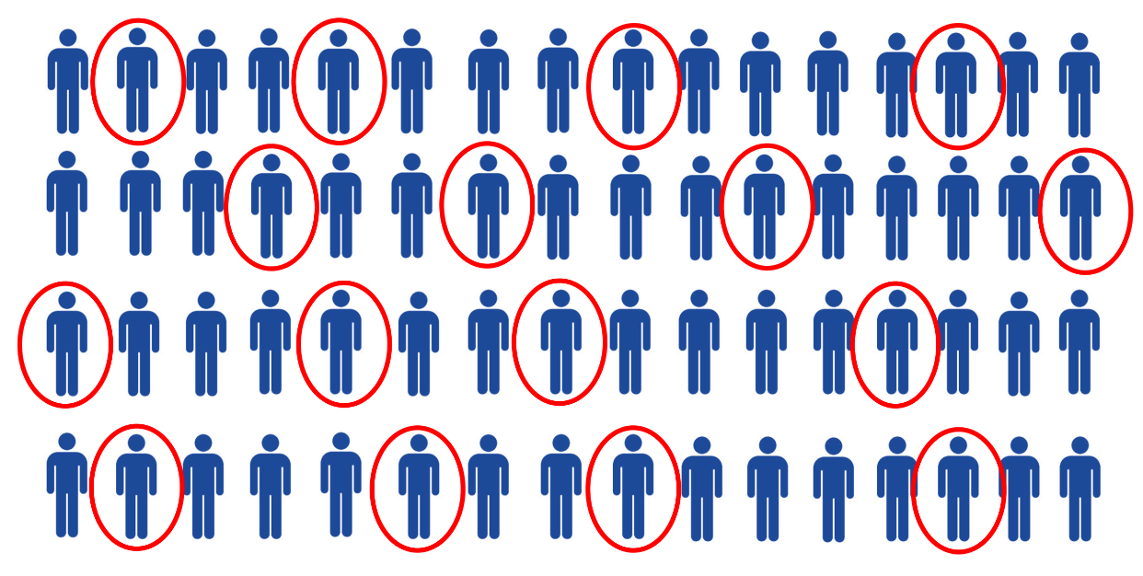

- Disability increases with age. In the over 65 age group 60 percent have a disability.
- Māori and Pacific people have higher-than-average disability rates.
- Half of all disabled people have more than one type of disability.
- 45 percent of disabled adults were employed compared with 72 percent of non-disabled adults. These employment statistics have not changed since 1996.
- 64 percent of disabled adults have an annual gross income of $30,000 or lower, compared with 45 percent of non-disabled adults. And, only 18 percent of disabled adults received an annual income higher than $50,000 compared with 33 percent of non-disabled adults.
- Disabled people are less likely to hold a formal qualification, with 67 percent holding a school or tertiary qualification compared with 85 percent of non-disabled adults.
- Disabled people experience discrimination more than non-disabled adults.
- Disabled adults and children were less likely to participate in many popular leisure activities than their non-disabled peers.

Building on our strengths
- DPOs represent disabled people. They are the voice of disabled New Zealanders. One DPO represents disabled people generally and the other six represent a particular disability group. The DPOs can provide you with a direct link to the collective and individual voices of disabled people.
- New Zealand has an international reputation for leading work on disability rights. Our vision of full citizenship and equal participation was first outlined in the New Zealand Disability Strategy in 2001. Disabled New Zealanders participated in the drafting of the UN Convention on the Rights of Persons with Disabilities between 2003 and 2007. In September 2014 the UN Committee on the Rights of Persons with Disabilities stated that New Zealand is now being held to account for the expectations they have set.
- The DPOs can provide real information and real experiences on how government systems are working for them. At the strategic level, the DPOs can provide advice on policy and priorities and help with real-life implementation and monitoring. As such, the DPOs are an invaluable resource for helping the government provide effective services and full citizenship to disabled people.
- Article 4.3 highlights the pivotal role that DPOs must play in implementing the UN Disability Convention, including that the government closely consult with and actively involve DPOs in all legislative, administrative and other measures undertaken to implement the UN Disability Convention.
- Our DPO report and presentations to the UN Committee in Geneva have been highlighted as best practice examples for other countries to look to. Our DPO report, written by DPA’s Senior Policy Analyst, Victoria Manning, is a concise report on disabled people’s rights. It brings together, under the Disability Convention framework, key reports, studies and recommendations that disabled people have spoken to over the last fifteen years.
- The National Government has brought together various threads of disability work setting a new context. Your job now is to push for progress.
- The Disability Action Plan 2014-2018’s vision is “All New Zealanders experience equal rights of citizenship”. It presents person-directed outcomes for some key areas requiring action. This new way of working is difficult and needs commitment from all involved. DPO priorities not on the current Disability Action Plan also require attention.
- The DPOs are committed to developing the DPO network to ensure disabled people are involved in the decisions that affect them. Discussions about the DPOs’ capacity and capability need to continue to ensure that the DPOs are sustainable into the future and to ensure leadership from disabled people on disability issues.

DPO priorities
- We want to work in partnership with you and government officials on the following priority areas.
- These DPO priorities below are taken from the DPOs shadow report. Most of the DPOs key priorities were incorporated into the Concluding Observations.
Note: The number in brackets is the relevant paragraph in the Concluding Observations (CO).
GREEN = priority being addressed ORANGE = priority partly being addressed RED = priority not being addressed
 | DPO priorities | In D.A.P | In C.O | In IMM | Notes
GREEN | Ensure that all public buildings are accessible (CO 20) |  |  |  | Building accessibility work is underway. An initial piece of work has assessed the issues. Work now needs to progress changes to the system.
GREEN | Ensure that all government agencies websites and information is accessible and complies with internationally recognised document and website accessibility standards (CO 20) |  |  |  | The CO reinforces the need for information to be made accessible to Māori and Pasifika disabled people (44).  The DAP action is to increase access to information, generally.  Work needs to ensure it includes improving compliance with the Government web standards and making these standards mandatory for local authorities, DHBs and Crown Entities.
GREEN | Establish the NZSL Board and monitor progress on NZSL initiatives (CO 42) |  |  |  | This is not in the DAP but is being progressed.
GREEN | Improve health outcomes for disabled people, particularly people with learning disabilities, Māori and Pasifika disabled people (CO 52 & 54) |  |  |  | This is in the DAP and DPOs keenly await progress.
GREEN | Increase the employment levels of disabled people (CO 56) |  |  |  | There is a high expectation to deliver this priority. The rate of disabled people’s participation in employment is very low and has hardly changed since 1993.
GREEN | Provide electronic voting as an option for the next local and general elections (CO 62)
GREEN | Review relevant legislation to ensure that disabled children have the same safeguards and are treated equitably to other children when placed in out of home care (CO 46) |  |  |  | This is a high level piece of work.  It is not yet clear in planning and resourcing whether the outcome sought by DPOs and disabled people will be achieved.
GREEN | Develop a plan to implement and monitor the new Government-DPO engagement principles across central and local government to ensure disabled people are involved in decision-making |  |  |  | This work is in the DAP, however a significant amount of further work is needed to enable implementation and monitoring across all government agencies.
ORANGE | Ratify the Optional Protocol (CO 6) |  |  |  | DPOs understand this is progressing but the timeframe for achieving ratification is not clear and this is a high priority for the DPOs
ORANGE | Increase the accessibility of public transport |  |  |  | To make this a Green priority, an action plan needs to be developed, with timeframes and targets, to increase the accessibility of public transport.  The DAP commits only to a stocktake of a 2005 Human Rights Commission Inquiry report and options for improvements. An action plan to progress real change is needed.
ORANGE | Extend choice in community living approaches so they are available to all disabled people (CO 40) |  |  |  | Although this is in each document the DAP commits only to reviewing current pilot programmes and defers, until 2015/16, ensuring [all] providers provide choice to disabled people and exploring providers performance accountability measures.  Choice in community living is a high priority for disabled people.
ORANGE | Replace the minimum wage exemption permit system with a better alternative (CO 58) |  |  |  | As a law change is required, this needs high level leadership to ensure this outcomes can be achieved.  Planning and resourcing needs to reflect the law change sought.
ORANGE | Review disability related costs to ensure sufficient allocation of compensation, particularly for disabled children and families (CO 60) |  |  |  | Disability related costs issues are highlighted in the IMM reports. It is reported that at times disability related costs are prohibitive and a barrier to full participation and equal citizenship for disabled people. Government financial supports often fall short of actual costs.  A review of this issue is sought.
ORANGE | Increase captioning and audio-description in broadcasting (CO 64) |  |  |  | The DPOs are not aware of any work on this. However, other priorities may be viewed as more fundamental.
ORANGE | Ratify the Marrakesh Treaty (CO 66) |  |  |  | The DPOs understand some work is happening towards achieving this.
ORANGE | Reinstate financial support to disability-inclusive development via the Pacific Disability Forum and the New Zealand DPOs (CO 72)
ORANGE | Revise all relevant laws to replace substitute decision-making with supported decision-making (CO 22) |  |  |  | This is in the DAP but the scope of work and resourcing required to achieve this outcome has not been well identified.  High level leadership is required to progress this as it could likely involve changes to statutes.  Progressing this work in line with the CRPD will involve high level and complex work planned to a clear end result. It will require significant resourcing, including ensuring high levels of DPO and disabled people involvement and legal expertise.  Discussions have focused on changing the PPPR Act, but the COs highlight there are a few laws (plural) to which supported decision-making applies.  This is a high priority for DPOs.
ORANGE | Develop a plan to raise the capacity and capability of DPOs so they can sustain themselves into the future and can ensure leadership on disability issues comes from disabled people |  |  |  | The Government has acknowledged the need to address DPO’s capacity and capability but work is in the very early stages.  This is a high priority for the DPOs to ensure that they are sustainable into the future and can effectively carry out their role in helping the government provide effective services and support to disabled people, and ensuring leadership on disability issues comes from disabled people.
RED | Review the Public Health and Disability Amendment Act 2013 to ensure that all family carers are paid on the same basis as other carers and remove limitations on the right to complain about such policies (CO 10) |  |  |  | This is a high priority for DPOs and it is not currently being progressed.  This is fundamental to ensuring equality for disabled people and ensuring the right to complain.
RED | Clarify the meaning of reasonable accommodation, and amend the Human Rights Act 1993 to include a definition of reasonable accommodation (CO 12) |  |  |  | The DAP covers only a narrow aspect of this work, ie: to develop guidelines on reasonable accommodation in employment (3a).  Reasonable accommodation needs clarifying at the highest level and in the Human Rights Act, to clarify its application across all statutes and all areas of people’s lives.  Clarifying reasonable accommodation is fundamental to ensuring disabled people can realise their rights.  The CO’s refer to reasonable accommodation in the Human Rights Act and education and justice (prisons).  A high proportion of disability complaints to the Human Rights Commission involve reasonable accommodation.  Prior work indicated by the Ministry of Justice to develop guidance on reasonable accommodation did not progress.
RED | Develop an action plan to improve outcomes for disabled women, including education and employment levels and in combating violence and abuse (CO 16) |  |  |  | Disabled women experience multiple discrimination and have not received much attention in leading disability documents.
RED | Develop an action plan to improve the situation of disabled children (CO 18) |  |  |  | The CO and the 2014 IMM report refer to the further work needed, including improving data on disabled children and ensure appropriate services and support. An action plan could plan out the work needed.
RED | Review the Mental Health (Compulsory Assessment and Treatment) Act 1992 to ensure full compliance with the Disability Convention (CO 30)  Take immediate steps to eliminate the use of seclusion and restraint in medical facilities (all facilities) (CO 32) |  |  |  | This is a high priority for DPOs.  The DAP deferred until 2015/16 exploring how the Mental Health Act relates to the BORA and the CRPD, but does not commit to changing the MH Act to ensure compliance with the CRPD.  The Government agreed to start preparatory work on this DAP action early, but no work appears to have been done.  The CO identified the elimination of seclusion and restraint in “medical facilities” but the DPOs view is that this must apply to all facilities, eg: prisons and residential services.  This work relates also to work around ensuring supported decision-making.
RED | Ensure work that will protect disabled people from violence and harm (CO 36) |  |  |  | The DAP defers until 2015/2016 a stocktake on reports and findings around violence and abuse of disabled people.  A 2008 Parliamentary Inquiry on this issue provided recommendations which need to be considered, among other recent reports and research.  Many disabled people are vulnerable and so protections from abuse and violence need careful attention.
RED | Enact legislation prohibiting the sterilization of disabled children and adults in the absence of fully informed consent, and using only supported decision-making (CO 38) |  |  |  | This is a high priority for DPOs.  It related to work on supported decision-making.  It requires high level commitment with planning to a clear outcome, and will require a high level of resourcing, including close involvement with DPOs and disabled people and legal expertise.
RED | Transform the education sector to an inclusive education framework, including provide an enforceable right to education for disabled people, ensure reasonable accommodations are provided within the inclusive education framework, reduce bullying of disabled students, and increase disabled peoples participation and achievement in tertiary education (CO 50) |  |  |  | The DAP does not address this priority to anywhere near the scope required. It lists only two light actions that were already in progress prior to the development of the DAP.  High level leadership is required to ensure real progress to achieving a fully inclusive education system.  Education is a high priority for DPOs and disabled people and parents. It is fundamental to realising our human rights.  Education has consistently been the largest category of disability related complaints received by the Human Rights Commission.  Recent reviews and work largely focuses on tweaking the system.  Transformation to an inclusive education system is sought, including clarifying reasonable accommodation in an inclusive education framework and an enforceable right to education.
RED | Government departments collect and publish disaggregated data on disabled people in their regular surveys and reports (CO 70) |  |  |  | Increasing data and information on disabled people is critical to fulfilling accountability and monitoring obligations and as evidence for implementing the CRPD.
- Priorities for Māori and Pasifika disabled people
RED | Raise outcomes for Māori children who are disabled, including in health and education (CO 18) |  |  |  | Māori disabled people are not well identified in disability work. Māori disabled people have cultural and disability perspectives that need to be incorporated.
RED | Increase access to information for Māori and Pasifika disabled people, especially deaf and deafblind (CO 44) |  |  |  | Access to information has been identified as a key barrier to Māori and Pasifika disabled people accessing disability information and services.
RED | Raise health outcomes for Māori and Pasifika disabled people (CO 54) |  |  |  | Health outcomes for Māori and Pasifika disabled people are of particular concern and need addressing urgently.
RED | Increase employment levels of Māori and Pasifika disabled people (CO 56) |  |  |  | Māori disabled people have a lower labour market participation rate than disabled people. Urgent and specific work is needed that raises Māori disabled and Pasifika disabled peoples participation in employment.

Progressing these priorities
- There are two overarching strategic priorities that will help progress several of the actions above, and help to implement several articles of the CRPD and recommendations of the Concluding Observations. These are:
- Clarify, in legislation and policy, reasonable accommodation obligations and examples to guide services and support to disabled people in all areas, including education and employment
- Ensure a Human Rights Approach is used in all services and supports provided to disabled people and in mainstream services and support
- The DPOs are a vital resource for helping to define and develop these two strategic overarching priorities, in addition to all actions to implement the CRPD.

References & Guiding documents
DPOs Shadow report
Disabled Persons Assembly NZ Inc. (2014) “New Zealand Disabled Person’s Organisations Report to the United Nations Committee on the Rights of Persons with Disabilities on New Zealand’s Implementation of the Convention on the Rights of Persons with Disabilities. 31st July 2014”.
http://www.dpa.org.nz/resources/sector-resources/the-united-nations-convention-on-rights-of-persons-with-disabilities/dpo-shadow-report

Convention Coalition reports
Convention Coalition Monitoring Group. “Disability Rights in Aotearoa New Zealand 2010: A report on the Human Rights of Disabled People in Aotearoa New Zealand” (2010).
Convention Coalition Monitoring Group. “Disability Rights in Aotearoa New Zealand 2012: A report on the Human Rights of Disabled People in Aotearoa New Zealand. (2012).
Convention Coalition Monitoring Group. “Disability Rights in Aotearoa New Zealand 2013: Youth. A report on the Human Rights of Disabled People in Aotearoa New Zealand. (2013), p 37.
http://www.dpa.org.nz/resources/sector-resources/the-convention-disability-rights-in-aotearoa-new-zealand

Independent Monitoring Mechanism reports
Human Rights Commission (2012) “Making Disability Rights Real Whkatūturu ngā Tika Hauātanga: Annual Report of the Independent Monitoring Mechanism of the Convention on the Rights of Persons with Disabilities 1 July 2011 – 30 June 2012”.
Human Rights Commission (2014) “Making Disability Rights Real Whkatūturu ngā Tika Hauātanga: Second Report of the Independent Monitoring Mechanism of the Convention on the Rights of Persons with Disabilities. Aotearoa New Zealand. July 2012 – December 2013”.
http://www.hrc.co.nz/disabled-people/convention-on-the-rights-of-persons-with-disabilities/making-disability-rights-real/

Short summary of the DPOs
Association of Blind Citizens of New Zealand Inc.
Founded in 1945, the Association of Blind Citizens of New Zealand Inc (Blind Citizens NZ) is New Zealand’s leading blindness consumer organisation and one of the country’s largest organisations of disabled consumers. Our aim is to heighten awareness of the rights of blind and vision impaired people and to remove the barriers that impact upon our ability to live in an accessible, equitable and inclusive society. We have a nation-wide membership of approximately 1,500 blind and vision impaired people who participate in our work via local branches and informal networks.
We work with government, providers of blindness and disability-specific services and, providers of both public and private services and accommodations, to raise awareness about the needs of blind and vision impaired people and, to remove the barriers so we too, can make our mark in the world. Blind Citizens NZ’s objects promote in every way, the interests, well-being and rights of blind and vision impaired people.
Balance New Zealand
Balance NZ is a national network of people who have lived experience of mental health distress (peers). We were formed in the mid-nineties as a network of manic depression support groups, and from there evolved to be actively involved in building and maintaining regional, national and international networks inclusive of all mental health peers. Balance NZ provides peer-led information, education, support, training, advocacy and research with our members to build healthier communities for us all.
Deaf Aotearoa New Zealand Inc.
Deaf Aotearoa is a Disabled Person’s Organisation and the New Zealand representative for the World Federation of the Deaf, the international body for Deaf people. Deaf Aotearoa works closely with government agencies, other not-for-profit organisations and the private sector to increase awareness of Deaf people’s lives, promote NZSL and strengthen the rights of Deaf people.
We work primarily with members of the Deaf community, as well as providing information and resources to the general public across a range of areas. Deaf Aotearoa is the national service provider for Deaf people in New Zealand. Deaf Aotearoa owns the only national New Zealand Sign Language interpreting service iSign, which provides interpreting services across all fields.
Deafblind (NZ) Incorporated
Deafblind (NZ) Inc. is a consumer-driven Society that works as an advocacy and support body for people in New Zealand who have this unique dual sensory loss. We encourage deafblind people and other people with disabilities to speak for themselves in order to improve their quality of life. Working with the Royal New Zealand Foundation of the Blind and several government departments we advise on the needs of people living with our dual disability to help break down the barriers that prevent full inclusion in society. We also encourage peer support as a vital aspect of our personal and group growth.
Disabled Persons Assembly New Zealand Inc.
Disabled Persons Assembly New Zealand Inc. (DPA) is the national assembly and collective voice of disabled New Zealanders. It is a member-driven organisation governed by disabled people. The organisation’s main purpose is to articulate the voice of its members who have all kinds of disabilities. DPA works in collaboration with other DPOs, allied NGOs and government to progress implementation of the Convention on the Rights of Persons with Disabilities in Aotearoa New Zealand.
DPA has some 900 individual members who are disabled or are the parent or guardian of a disabled person and some 200 corporate members who represent or deliver services to disabled people. DPA members form a network of regional assemblies to debate local and national issues.
On the international stage, DPA is New Zealand’s representative member of the Disabled Persons International and Rehabilitation International.
Ngāti Kāpō O Aotearoa Inc.
Ngāti Kāpō O Aotearoa Inc. (Ngāti Kāpō) is an indigenous Disabled Persons Organisation (DPO) founded by kāpō (blind, vision impaired and deaf blind) Māori and their whānau with membership open to any person who supports the Society’s purpose and aims, which, are founded upon Māori cultural philosophy, protocols and practices.
Ngāti Kāpō is charged by its members to create, facilitate and or contribute in the advancement of strategic and service solutions that assist Ngāti Kāpō members to attain whānau ora, thus realising their potential as individuals, as whānau and as contributing citizens in Aotearoa New Zealand society.

People First New Zealand Inc. Ngā Tāngata Tuatahi
People First New Zealand Inc., Ngā Tāngata Tuatahi is a national self-advocacy organisation that is led and directed by people with learning (intellectual) disability. People First NZ works in a human rights framework to empower and assist people with learning disability to be strong and valued citizens of New Zealand. People First NZ is governed by its National Committee – made up of 6 elected Regional Presidents (people with learning disability) and 2 non-voting advisors
People First NZ has 30 local self-advocacy groups throughout New Zealand and members speak up locally, and nationally about issues that are important to them. People First NZ also has an education arm, Learn with us, an Easy Read Translation Service and undertakes project work.
People First NZ Inc. is part of an international social justice movement advocating for the rights and inclusion of all people with learning disability.

Human Rights Approach
The human rights approach has been developed internationally and adapted for New Zealand by the New Zealand Human Rights Commission, it requires:
- linking of decision-making at every level to human rights standards set out in the relevant human rights covenants and conventions
- identification of all relevant human rights involved and a balancing of rights, where necessary prioritising the rights of the most vulnerable people, to maximise respect for all rights and rights-holders
- an emphasis on the participation of individuals and groups in decision-making affecting them
- non-discrimination among individuals and groups through the equal enjoyment of rights and obligations by all
- empowerment of individuals and groups by their use of rights to leverage for action and to legitimise their voice in decision-making
- accountability for actions and decisions, enabling individuals and groups to complain about decisions adversely affecting them.

Disability Action Plan 2014-2018: cross government priorities to make a difference.
United Nations Convention on the Rights of Persons with Disabilities, Committee on the Rights of Persons with Disabilities. “Concluding observations on the initial report of New Zealand.” 3 October 2014.
Independent Monitoring Mechanism reports 2012 and 2014.
See description at the end of document. Human Rights Commission (2013) “Annual Report 2013 Pürongo ä Tau 2013” Human Rights Commission: Wellington. P 9.
Human Rights Commission (2013) “Annual Report 2013 Pürongo ä Tau 2013” Human Rights Commission: Wellington. P 9.
“Disabled People’s Organisation (DPO) Roles and Attributes. Working draft – 3 December 2013; and Office for Disability Issues. (2014). “Disability Action Plan 2014-2018: New Zealand’s priorities to advance implementation of the United Nations Convention on the Rights of Persons with Disabilities and the New Zealand Disability Strategy.” (May 2014). P 3.
Office for Disability Issues. (2014). “Disability Action Plan 2014-2018: New Zealand’s priorities to advance implementation of the United Nations Convention on the Rights of Persons with Disabilities and the New Zealand Disability Strategy.” (May 2014). P 3.
Convention Coalition Monitoring Group. “Disability Rights in Aotearoa New Zealand 2012: A report on the Human Rights of Disabled People in Aotearoa New Zealand. (2012). P 30; and New Zealand Government Cabinet Paper. “Choice in Community Living.” Accessed on 18 June 2014 at http://www.health.govt.nz/system/files/documents/pages/choice-in-community-living.pdf
“New Zealand Disabled Person’s Organisations Report to the United Nations Committee on the Rights of Persons with Disabilities on New Zealand’s Implementation of the Convention on the Rights of Persons with Disabilities. 31st July 2014”. Report prepared by DPA NZ Inc.
Ibid.
Statistics New Zealand. Disability Survey 2013. Accessed on 15 October 2014 at: http://www.stats.govt.nz/browse_for_stats/health/disabilities/disabilitysurvey_hotp2013.aspx
Ibid.
Ibid.
Ibid.
Statistics New Zealand (2014). Social and economic outcomes for disabled people: Findings from the 2013 Disability Survey. Wellington: Statistics New Zealand. P 5.
Human Rights Commission. (2012). “Making Disability Rights Real Whakatūturu ngā Tika Hauātanga: Annual Report of the Independent Monitoring Mechanism of the Convention on the Rights of Persons with Disabilities 1 July 2011 - 30 June 2012.” P 81; and Human Rights Commission. (2014). “Making Disability Rights Real Whakatūturu ngā Tika Hauātanga: Second Report of the Independent Monitoring Mechanism of the Convention on the Rights of Persons with Disabilities. Aotearoa New Zealand. July 2012 - December 2013.” P 85
Ibid.
Ibid.
Ibid.
Ibid.
Ministry of Health. (2001). “The New Zealand Disability Strategy: Making a World of Difference. Whakanui Oranga” April 2001 P 5; and Office for Disability Issues. (2014). “Disability Action Plan 2014-2018: New Zealand’s priorities to advance implementation of the United Nations Convention on the Rights of Persons with Disabilities and the New Zealand Disability Strategy.” (May 2014).
“New Zealand Disabled Person’s Organisations Report to the United Nations Committee on the Rights of Persons with Disabilities on New Zealand’s Implementation of the Convention on the Rights of Persons with Disabilities. 31st July 2014”. Preport prepared by DPA NZ Inc.
Human Rights Commission. (2012). “Making Disability Rights Real Whakatūturu ngā Tika Hauātanga: Annual Report of the Independent Monitoring Mechanism of the Convention on the Rights of Persons with Disabilities 1 July 2011 - 30 June 2012.” P 29.
Disabled Persons Assembly NZ Inc. (2014) “New Zealand Disabled Person’s Organisations Report to the United Nations Committee on the Rights of Persons with Disabilities on New Zealand’s Implementation of the Convention on the Rights of Persons with Disabilities. 31st July 2014
Human Rights Commission. (2012). “Making Disability Rights Real Whakatūturu ngā Tika Hauātanga: Annual Report of the Independent Monitoring Mechanism of the Convention on the Rights of Persons with Disabilities 1 July 2011 - 30 June 2012.” P 29.

